# PROCEDURE

GIT SIGN IN

1. Go to github.com.

2. Sign in & create account.

3. Create /upload file in folder inside repository.

FIGMA SIGN IN

1. Go to figma.com.

2. Sign in with your enrollment number.

3. On Figma home page click on design file.

4. Give title to your file.

EX: File is “PROTOTYPE”

Page 1: HOME PAGE.

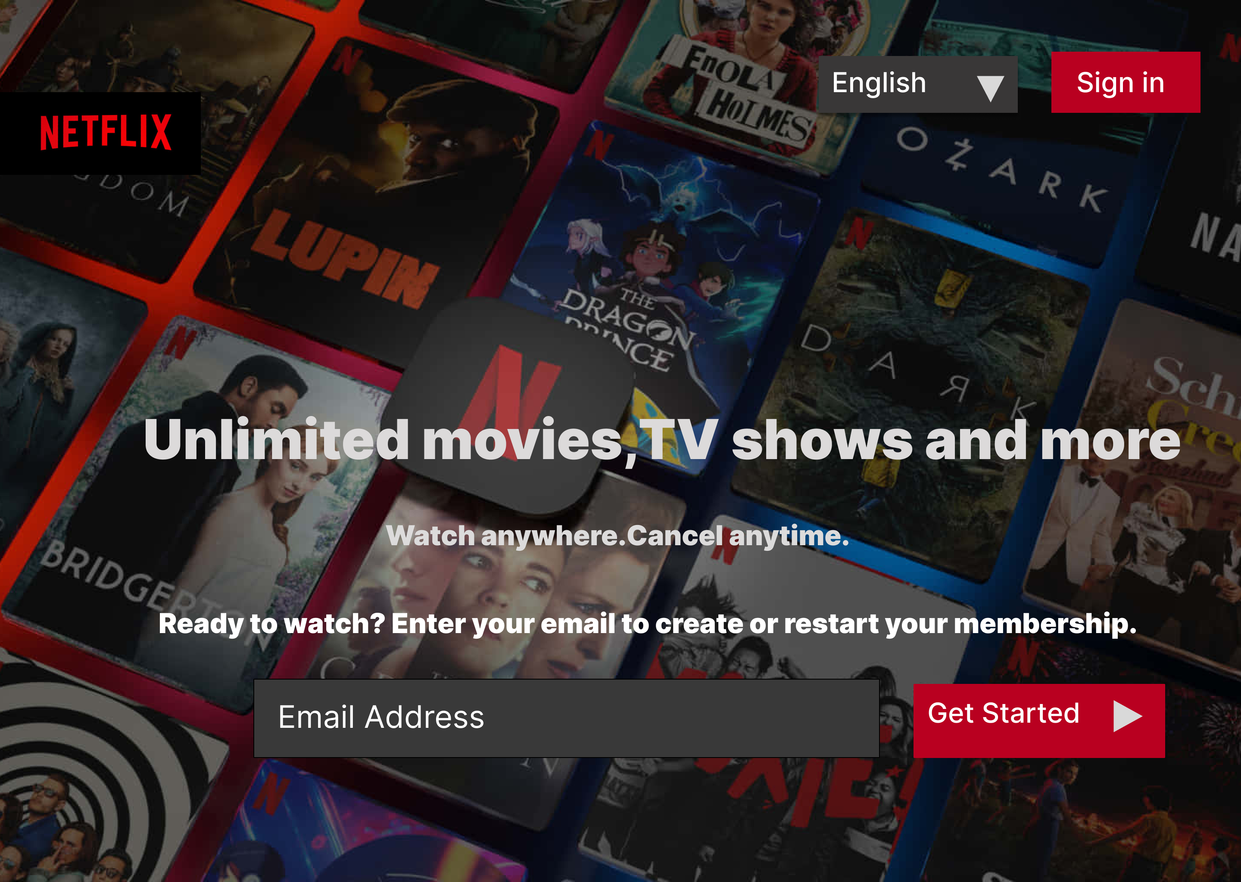

# Page 2: Sign in page

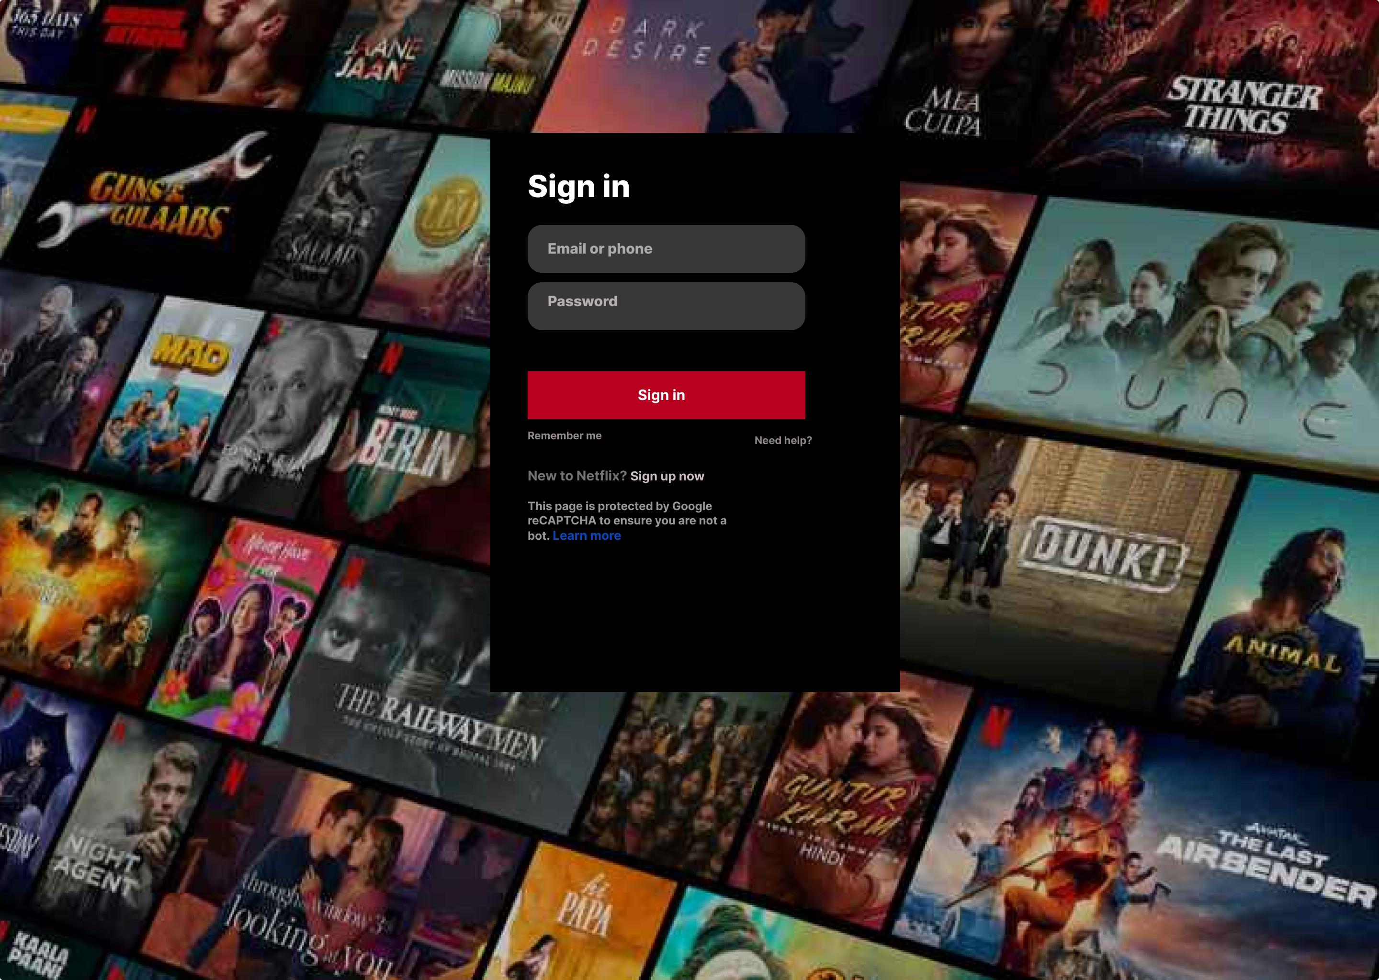

# Page 3. NETFLIX LOGO.



# Page 4.



# Page 5. : AVAILABLE OFFLINE ONCE DOWNLOADED.

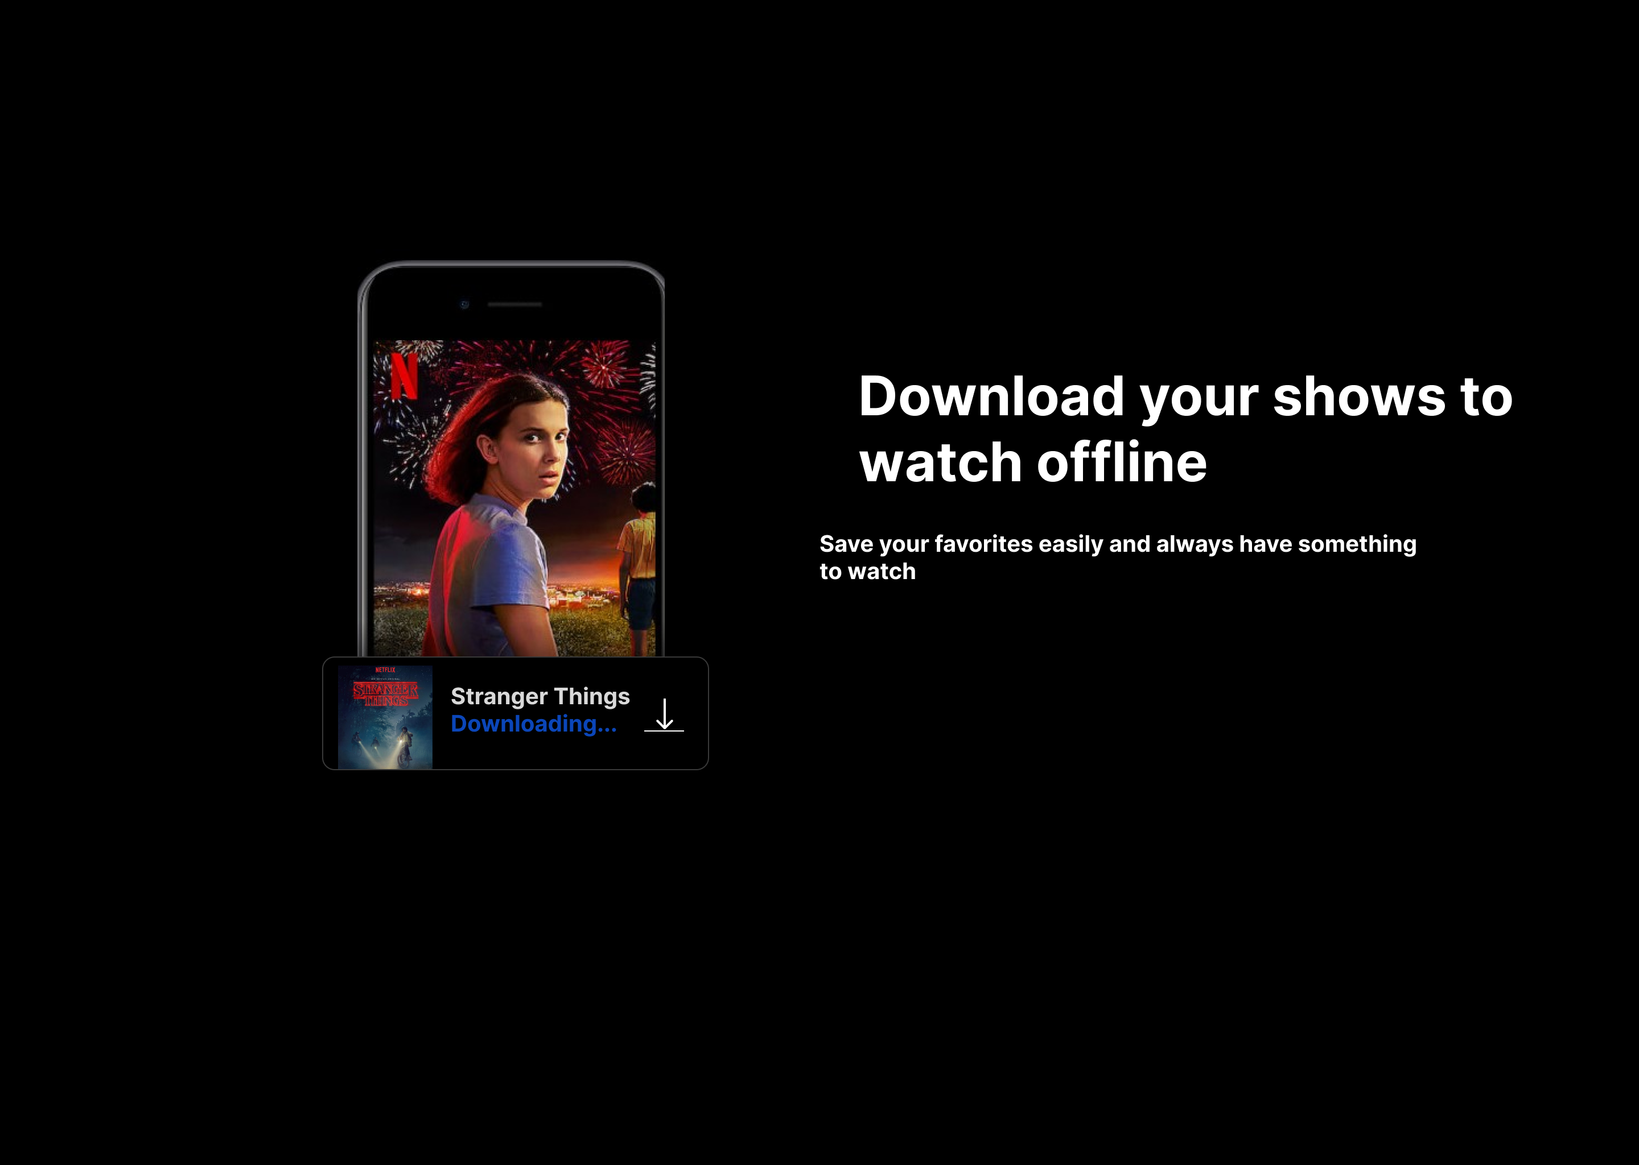

# Page 6. AVAILABILITY ON DEVICES.

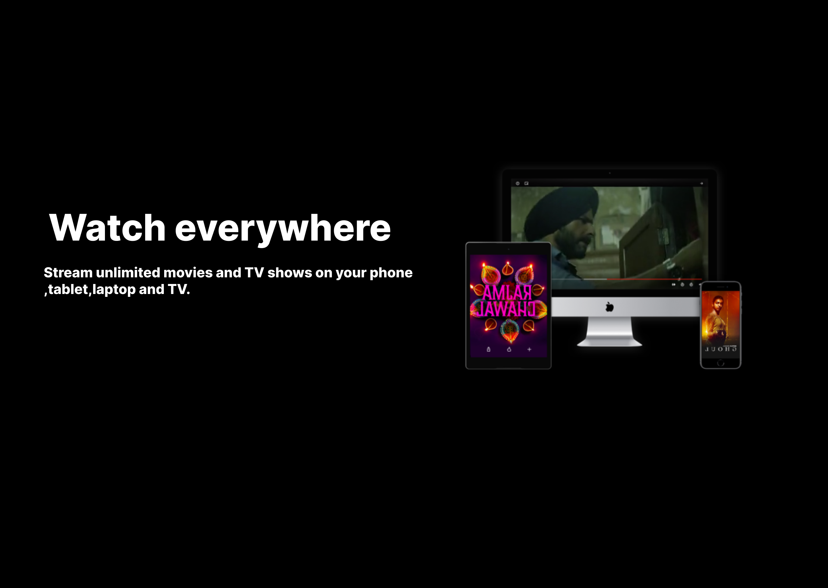

# Page 7.: PROFILE FOR CHILDREN

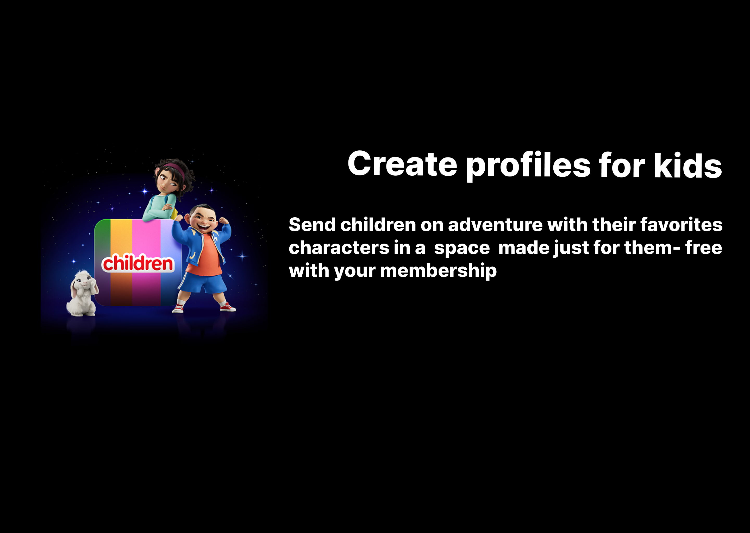

# Page 8.: QUESTIONS REGARDING NETFLIX.

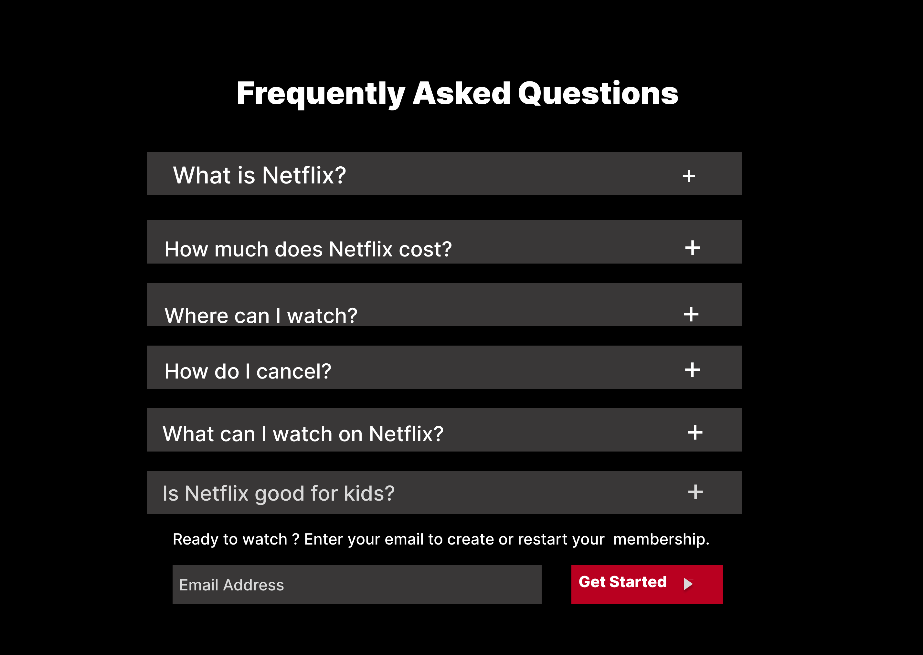

# Page 9.: HELP PAGE.

